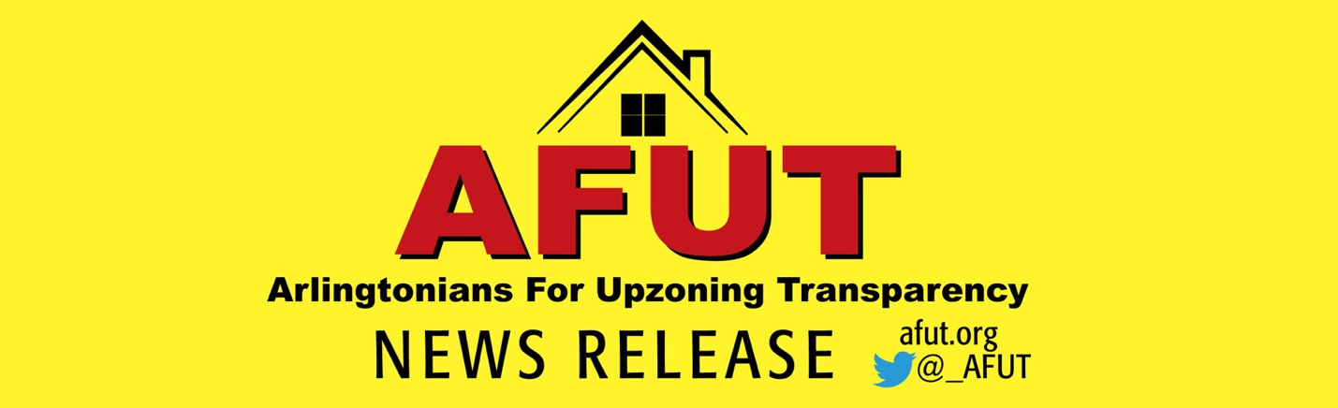

AFUT Testimony to Arlington County Board

For Immediate Release: January 24,

I am David Gerk, an Arlingtonian since 2002. I am an attorney, an engineer, and have two girls - ages 5 and 2.

I speak tonight on behalf of Arlingtonians for Upzoning Transparency (AFUT). AFUT’s mission states “developing AFUT’s mission states “developing housing that is more affordable, encouraging diversity, and righting imbalances that have led to housing inequalities in Arlington is something we all want.”

We have heard supporters of the Missing Middle Housing Plan repeatedly say they want more affordable housing they can own and is sized for families. But this upzoning Plan won’t achieve any of these goals – and tragically, you know it.

- You know that 30% of Arlington’s homes are already Missing Middle – only 24% are single family. Missing Middle is neither missing nor for the middle.

- You know this Plan will create some owner and mostly rental housing that is more expensive than what we have now, accelerating teardowns in Arlington’s most affordable neighborhoods.

- You know this Plan will NOT help public workers or low- or-moderate income folks of any color.

- You know this Plan will accelerate gentrification and make us less diverse.

- You know this Plan will displace many of Arlington’s 1 in 4 cost-burdened senior households.

- You know this Plan will create housing only affordable for higher income workers – not our service workers.

- You know the Board has always had the power to solve the “McMansion/teardown” problem, but is unwilling

- You know that across the country, land prices are highest and grow fastest in areas with dense housing - and this Plan is really about revenue generation.

- You know this Plan will result in more overcrowded schools, decimated tree canopy, increased flooding, monstrous traffic and parking congestion and higher taxes.

- You know this Plan was created through a non-transparent, intentional process designed to minimize engagement, tear the community apart and pit neighbors against neighbors.

- And thousands of Arlington residents are unaware of what is in store for them.

Board members have talked about finding consensus. AFUT challenges you to make this happen. How?

We call on you to abandon this plan, bring people together and convene a community-based working group with appropriate expertise to develop real and effective solutions vetted by robust residential input. Ensure discussions are based on economic and factual analyses and support the broader planning context of Arlington priorities.
AFUT’s plan should sound familiar because it is the Arlington Way. It was a successful blueprint that made Arlington one of the best places to live.
It’s not too late to create a Plan the community supports. Arlington’s future depends on it.

# # #

Media Contact: Julie Lee, jfblee@aol.com

