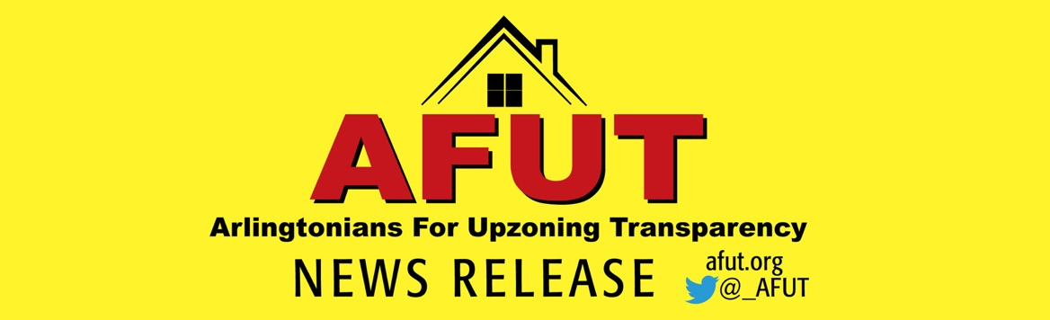

FOR IMMEDIATE RELEASE: January 25, 2023

AfUT Condemns Arlington County Board Unanimous Decision to Move Forward on Flawed Missing Middle Housing Plan That Ignores Strong Community Opposition

AfUT strongly condemns tonight’s move by the Arlington County Board to approve a Request to Advertise (RTA) public hearings on zoning and General Land Use Plan (GLUP) amendments (now scheduled for March 18) to implement its Missing Middle Housing (MMH) Plan. The Board approved the RTA despite the opposition of thousands of Arlington residents. More than 5,600 people have signed an online petition opposing the Board’s plan to end single-family zoning and allow by-right development of multi-family buildings, including 6-plexes, across Arlington. In the County’s own July 2022 survey, 75% of respondents opposed the Plan.

Going forward, only the options included in the approved RTA will be considered in the final March vote. The RTA allows up to three townhouses and multi-family buildings with 2 to 6 units on single-family properties throughout Arlington. By allowing by-right development for builders, which is included in all of the RTA options, the County Board has ceded its authority to review MMH construction for neighborhood compatibility.

Speakers at the January 21 and 24 public hearing cited Arlington County’s own data to show why the Plan will not create housing that is more attainable to low-and-moderate income residents. Supporters of the Missing Middle Housing Plan repeatedly said they want more affordable housing they can own and is sized for families. But this upzoning Plan won’t achieve any of these goals. Instead, the Plan will actually create owner and rental units that are more expensive than existing housing (see page 20), and further diminish the supply of homes that are most affordable through teardowns while displacing renters, persons with disabilities, seniors and diverse residents.

Even Arlington County Board Member Katie Cristol admits that there will be “initial sticker shock” with new MMH. Given that the Board doesn’t expect the Plan to provide housing that is more affordable, there is no reason for its rush to vote on the RTA and for a final vote in March.

The County continues to encourage the misinformation that has erroneously convinced many residents that the Plan will create housing affordable to teachers, firefighters, bus drivers, custodians, or middle-or low-income workers; create more three-bedroom homes; and create more home ownership opportunities. But facts are facts – and the MMH Plan does none of these. The Plan will not make it any easier for these valued workers to live in Arlington.

AfUT (Arlingtonians for Upzoning Transparency) supports developing housing that is more affordable, encouraging diversity, and righting imbalances that have led to housing inequalities in Arlington. Unfortunately, the current MMH Plan will exacerbate these imbalances and lead to increased gentrification and less diversity, just as upzoning has done along Arlington’s Columbia Pike corridor. Six of Arlington’s 10 highest appreciating neighborhoods are located in or proximate to Columbia Pike’s already upzoned Form Based Code neighborhoods, it’s clear that densification fuels housing costs, making housing even less affordable for all Arlingtonians. A recent report showed why the one in four senior households in Arlington that are cost-burdened will be especially threatened by the rising property values and taxes that will inevitably be the result of the MMH Plan.

County staff have estimated that a one to two-bedroom unit in a 6-plex would cost $670,000, with monthly housing costs of $3,300. According to a mortgage loan specialist who spoke at the AfUT/ASF (Arlingtonians for Our Sustainable Future) January 8 Reality Check Rally, a household income of $173,813 would be required to purchase a unit costing $670,000. That is 136% of Area Median Income (AMI), which is considered upper income – and far above the median income of Arlington African American households ($66,781) and Latino households ($86,513). It also is beyond the average income of an Arlington teacher ($62,198), Arlington firefighter ($70,018), and Arlington police officer ($68,600).
Speaker after speaker at the public hearing criticized the County’s non-transparent, public process as intentionally designed to minimize engagement, tear the community apart and pit neighbors against neighbors. Instead of trying to find common ground, the County has stoked division about Arlington’s decades-old land use policy of focusing density along transit corridors and preserving single-family neighborhoods.
One of the arguments Arlington has made is that MMH is the only alternative to the phenomenon of teardowns that result in construction of so-called McMansions.
“It is a false choice to say that MMH is the only option to McMansions, which the County Board acknowledges are a problem.” said Julie Lee, a founding member of AfUT. “It is completely within their power to change zoning requirements and reduce the size and number of McMansions being built. But they have refused to take action. The MMH Plan will incentivize developers to tear down modest, single-family homes and build $1.5 million townhouses and duplexes or small one-and-two-bedroom rental units. The County should not promote the false premise that the free market will produce lower cost housing. Developers will build the most profitable – and most expensive -- MMH possible, using every bit of allowable lot coverage to do it.”

AFUT member David Gerk, an attorney and engineer with young children, says of this divisive approach: “Anyone who goes beyond the County’s bumper sticker rhetoric and looks at the facts can plainly see this Plan will do nothing to rectify ills in America’s or Arlington’s past and it certainly won’t solve the real challenges Arlington faces today – it will actually exacerbate them. We invite the Board to start leading and governing in a responsible way, to work with our local talent pool of economists, realtors, developers, architects and others, to come up with a plan that truly will make Arlington the inclusive, diverse community that we all want.”
Multiple speakers at the public hearing called on the County Board to abandon the flawed MMH Plan, including AfUT. Gerk said, “Bring people together and convene a community-based working group with appropriate expertise to develop real and effective solutions vetted by robust residential input. Ensure discussions are based on economic and factual analyses and support the broader planning context of Arlington priorities. AFUT’s plan should sound familiar because it is the Arlington Way. It was a successful blueprint
that made Arlington one of the best places to live.”
Media Contact: Julie Lee, jfblee@aol.com

