

**For Immediate Release: January 17, 2023**

**Arlington's Missing Middle Housing Plan Undermines County Board Chair's Principles for Housing Policy**

Arlingtonians for Upzoning Transparency (AFUT) issued the following letter to County Board members on January 12 concluding that the County's Missing Middle Housing Plan undermines the principles that County Board Chair Christian Dorsey recently advanced for housing policy in Arlington.

The analysis is based on extensive research that was shared during the January 8 Reality Check Rally, sponsored by AFUT and Arlingtonians for Our Sustainable Future, and attended by more than 500 residents.  During the rally, real estate and land use experts urged the County Board not to vote on its Plan on January 21.

David Gerk, an attorney, engineer and AFUT member who sent the letter to the Board on behalf of AFUT states: "Many residents who support the County's Missing Middle Housing Plan do so because they think it will make housing in Arlington more affordable.  But it won't. A one-bedroom unit in an 8-plex will require an income of $150,000 - more than two times the median income of African American households in Arlington.”

The experts' slides from their presentations are available on the AFUT website:  
[afut.org](http://afut.org/).

January 12, 2023

Dear Chairman Dorsey and Members of the County Board:

In your January 3, 2023 remarks, Chairman Dorsey, you advanced five principles that should guide Arlington’s housing policy. Arlingtonians for Upzoning Transparency (AFUT) agrees that these principles are an important lens for assessing Arlington’s housing policy.

But the County’s proposed zoning and General Land Use Plan (GLUP) amendments to implement its Missing Middle Housing (MMH) Plan not only fail to advance any of the five principles, they undermine them.

More than 500 residents attended the Reality Check Rally on January 8th sponsored by AFUT and Arlingtonians for Our Sustainable Future (ASF). The Rally featured speakers who are Arlington residents with experience in land use and real estate, including two former Planning Commission chairs, an economist, a realtor, a mortgage loan specialist, a consumer protection attorney, an engineer/attorney, and a real estate consultant who worked with Arlington County on the Clarendon Sector Plan.

These experts agree that the County Board should not vote on January 21 on the Request to Advertise. We apply their thorough analyses to demonstrate that the proposed zoning and GLUP amendments:

• Will make Arlington less diverse;

• Ignore the thoughtful views of experts and its own advisory groups;

• Are not needed to meet the Metropolitan Washington Area Council of Governments’ (COG) goals for housing in Arlington and lack the necessary analysis and planning to begin an iterative process;

• Leave behind low, moderate, and middle-income households – with a one-bedroom unit in an 8-plex requiring a household income at 117% of AMI; and

• Are not integrated with our interconnected priorities for transportation, the environment, and job growth.

You made a pledge, Chairman Dorsey, “to forge a path on Missing Middle and all other questions concerning growth and change, that reflect [the five-housing policy] principles” and you called on the community to engage “with an eye towards holding us, the County Board, accountable for moving forward thoughtfully and reasonably given all the positions that may be held on any given issue.”

AFUT is doing just that. We offer the analysis below in that spirit of accountability with a focus on the five housing principles.

Chairman Dorsey:

**“First, Arlington should be open to all. Inclusive communities are dynamic and best positioned to be resilient. Barriers to entry should be identified and dismantled. This is a foundation principle.”**

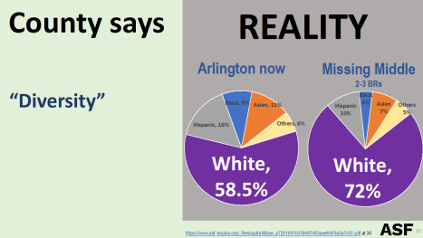

Because the cost of the least expensive of the proposed units is well beyond the median income for African American and Latino households in Arlington, the MMH Plan will result in less diversity here, not more.

Chairman Dorsey:

**“Second, our planning for the future should, as always, be community based, and that means engaging all stakeholders in our community and incorporating all thoughtful views.”**

The County’s community engagement that began in 2019 was based on a MMH framework with a limited scope and goals of affordability and home ownership. But the scope and goals of the MMH Framework have changed significantly, without meaningful community engagement on the changed Plan.

In 2019, the County promised that the plan was not:

• An across-the-board rezoning of all single-family areas

• A process to eliminate single-family zoning in Arlington

• A process to codify decisions that have already been made.

But the proposed amendments are a de facto rezoning of all R-5 through R-20 single-family zoning districts to allow multi-family buildings.

Residents who were aware of the MMH Plan years ago were suspicious of the County’s 2019 claims as to its scope. Residents continue to be suspicious about the MMH Plan in light of that history and the contrast between County claims about the Plan and the realities that AFUT and ASF have brought to light.

In terms of the Plan’s goals, residents were led to believe that the Plan was intended to help teachers and other middle-income households to afford housing in Arlington. Board members stated as much:

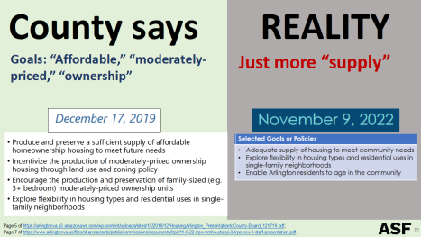

Residents have not understood that the County’s goals are to increase housing supply and to diversify housing types. Many are incredulous when they learn this.

A fundamental shift in Arlington’s land use planning to address our future needs should begin with a community conversation about our vision for the future. This process can create community consensus. Instead the MMH Study process has created a schism in the County and distrust of its leaders.

Chairman Dorsey:

**“Third, planning should be iterative, allowing us to course correct when necessary and evolve over time.”**

Iterative planning can be useful. But all planning must begin with a solid foundation. That includes clearly defined needs and goals to meet those needs.

The County Manager’s draft amendments made public in early December 2022 note that the Board initiated the MMH Study in 2019 in part because of COG’s report citing the “need to add 320,000 homes in the Washington D.C. area between 2020 and 2030 to keep pace with forecasted growth.”

But the Manager fails to quote COG’s statement: “This is an additional 75,000 units beyond what is already forecast for this period.” The need is 75,000 more units across the metro area by 2030. And Arlington’s own Housing Director stated in 2022: “We can confidently say we do have enough housing capacity within our current plan to enable the production that COG has for Arlington targets.”

Arlington is meeting COG’s goals for the number of housing units needed, without implementing the MMH Plan. So why is the Board rushing to implement its MMH Plan with more housing units than COG identifies as needed?

And, the MMH Plan does not meet the original goal of adding more 3-bedroom housing units.  Instead, it incentivizes developers to tear down existing single-family homes with 3 or more bedrooms and build multi-family buildings with 1 or 2 bedrooms.

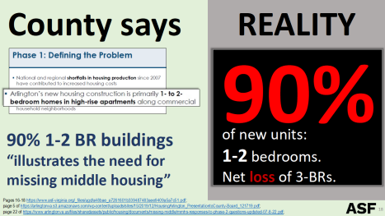

As noted above, the goals of the MMH Plan have changed over time. The goals should not be iterative, but foundational. And these should be based on a vision for our future that is expressed through amendments to Arlington’s Comprehensive Plan after a thoughtful community process. Only then should zoning amendments be considered.

In addition, the impact of any land use planning must be studied before adopting significant zoning and GLUP changes. Adopting a plan now, and waiting to see the impact, is not an iterative planning process – it is an irresponsible one.

While the County promised a responsible, fact-based process, there has been little or no analysis on the impact of the Plan.

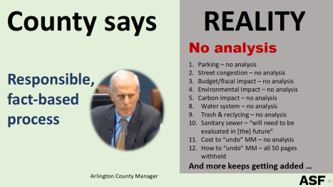

Arlington is known for its comprehensive, thoughtful land use planning. The MMH Plan process has not lived up to that reputation.

Chairman Dorsey:

**“Fourth, to the greatest extent practicable, living anywhere in Arlington should not be determined by income levels. Our attention to vibrant and diverse communities should span across all our 26 square miles.”**

Allowing by-right development of multi-family buildings in R-5 through R-20 zoning districts deregulates land use and relies on the market to supply housing that is more affordable than it is now.

This is premised on the false assumption that increased supply of housing in Arlington will lower prices. The economic principle that increased supply lowers costs is countered on the demand side of the equation in Arlington’s housing market due to our small geographic area, increasing population, high per capita income, proximity to D.C., and other factors contributing to the strong demand to live here.

Instead, the experts’ analyses demonstrate that housing costs will increase as developers compete with individuals to purchase single-family homes, such as ramblers and Cape Cods.  The developers will win that competition and replace smaller, more reasonably priced single-family homes with multi-family homes. Prices of single-family homes will increase through both the competition with developers and the decrease in supply of these homes.

The units that will replace these single-family homes are not attainable for most Arlington residents. The analysis of a mortgage loan specialist with more than 30 years’ experience in the mortgage loan industry, and a degree in economics, provided more accurate assumptions about interest rates, down payments, and debt – reflecting the 2023 market, not the 2019 market of the County’s assumption. This analysis shows that the income needed to qualify for a mortgage to purchase a one-bedroom unit in an 8-plex is $150,000 – 117% of Arlington’s AMI – and well above the median incomes of teachers, senior citizens, and African American and Latino households.

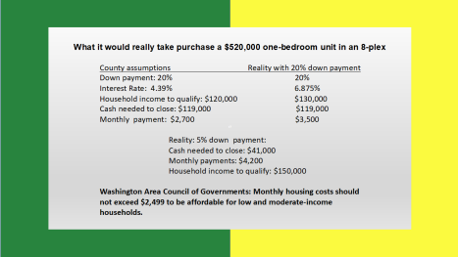

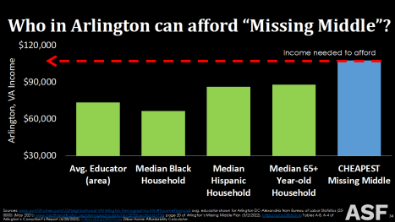

And the monthly payment for such a unit would be $4200, well above the $2,999 that COG suggests should be the maximum monthly housing costs to be affordable for low- and moderate-income households. COG also states that 75% of the new housing that is needed in the region should meet this goal.

Chairman Dorsey:

**“Fifth, planning to meet our housing goals must be integrated with our interconnected priorities of: creating transit and active transportation-oriented communities that are safe for all users; reducing greenhouse gas emissions; and attracting and retaining employers that support good jobs for workers.”**

The County estimates that 84% of its population growth between 2020 and 2045 will be in the planning corridors.

The Master Transportation Plan includes this goal: “Organize community development and redevelopment around high quality and high capacity transit.”

In addition, COG recommends that 75% of the new housing that is needed in the region be near transit or activity centers.

Arlington’s MMH Plan creates no incentive for housing to be focused in these areas, but instead disperses new units across the County, including areas with little or no public transit.

The importance of integrating housing goals with other interconnected priorities has been recommended by the County’s Joint Facilities Advisory Commission, which recommended in April 2022 that the MMH Study be used to inform “an expanded long-range vision for Arlington as a whole, including consideration for transportation, diversity, equity, parks, environmental conservation, sustainability, and schools and public facilities.”

The County’s many planning processes regarding housing and its impacts should be incorporated into the MMH Plan, such as the home ownership study, Plan Langston Blvd., and others.

**Other Options to Advance Housing Policy Principles**

The County’s MMH Plan not only fails to advance your housing policy principles, Chairman Dorsey, but it undermines them.

At the Rally, experts addressed many other options, including low interest loans for first-time home buyers, tax credits, subsidies for closing costs, accessory dwelling units, and converting commercial office space.

**Next Steps**

So where should the County go from here?

Given that the draft zoning and GLUP amendments do not advance any of these guiding principles for housing policy, the Board should not vote on its Request to Advertise on January 21.

In addition, the County should not vote until it has adequately studied the impact of its proposed plan on trees, roads, stormwater management, schools, and more, as the Rally experts discussed.

Instead, the Board should convene a panel of experts to review the proposed MMH Plan, and options in addition to increasing the supply of missing middle housing, that would meet these important housing policy goals. Then it should engage in a meaningful community engagement process to consider the experts’ recommendations.

AFUT stands ready to assist in this process and expects that many of the experts who spoke at the Rally would do so as well.

**Media Contact:** Julie Lee, jfblee@aol.com. AFUT